INFORMATION WARFARE
“Information Warfare, in its most fundamental sense, is the emerging ‘theatre’ in which future nation-against-nation conflict at the strategic level is most likely to occur”.
– George J. Stein, Cyber War, 2000.
- IW can be defined as actions taken to achieve ‘information superiority by adversely affecting the adversary’s information, information-based processes, information systems, and computer-based networks whilst simultaneously protecting one's own information, information-based processes, information systems and computer-based networks’. Correct and timely information made available to commanders at all levels contributes directly to effective Command and Control (C²) and helps in shortening the Observe-Orient-Decide-Act (OODA) Cycle (also known as the OODA Loop). IW has a vital impact upon the first three activities of the OODA Loop by disrupting the enemy's observation and surveillance systems, corrupting his orientation and misguiding his perception and thereby inducing him to arrive at wrong decisions.
- Objectives of IW. The basic ingredients of IW are collection of data, sifting (to extract relevant information), analysis and assimilation of information to create intelligence which will help to achieve the objectives of IW. These objectives are:-
  - Develop and maintain a comprehensive information base of the capabilities of adversaries and forecast their likely actions.
  - Deny information about own and friendly forces to adversaries.
  - Influence perceptions, plans, actions and the will of adversaries to oppose own and friendly forces by offensive employment of IW techniques.
  - Influence non-combatant and neutral organisations to support friendly missions or, at least, not to resist friendly activities.
  - Protect friendly decision-making processes, information and information systems.
  - Degrade the information systems of adversaries.
Forms of IW
- The seven forms of IW are Command and Control Warfare (C²W), Intelligence Based Warfare (IBW), Electronic Warfare (EW), Psychological Warfare, Cyber Warfare, Economic Information Warfare and Network Centric Warfare (NCW). These are discussed in succeeding paragraphs.
- Command and Control Warfare. The aim of C²W is to influence, deny information to, degrade or destroy enemy C² capabilities while protecting own C² systems against such actions. C²W is a dominant component of IW in the military arsenal. C²W operations integrate and synchronise the capabilities of EW, military deception, physical destruction, psychological operations and operational security.
- Intelligence Based Warfare. IBW is a traditional component of IW and occurs when intelligence is directly fed into operations (notably targeting and battle damage assessment) to bring transparency to the battlefield rather than being used as an input for overall C². IBW is the direct application of battlefield intelligence instantaneously into the battle and aims at creating an asymmetry in the level of transparency or situational awareness in relation to the enemy.
- Electronic Warfare. EW is a set of military actions taken to deny the use of the electro-magnetic spectrum to hostile forces while retaining the ability to use it oneself. This basically implies that the endeavour is to deny, degrade, delay or disrupt information in order to create a false picture so that the enemy is duped into making incorrect assessments and taking wrong actions. EW involves the use of electro-magnetic and directed energy to control the electro-magnetic spectrum or to attack the enemy. One of the most important developments in the field of EW has been the introduction of automated and integrated EW systems, which provide a high degree of information in addition to interception, direction-finding and jamming activities.
- Psychological Warfare. Information is one of the several means to target the human mind. Psychological warfare is achieved through mass media such as newspapers, radio and television broadcasts and distribution of leaflets. The prevailing state of information technology allows effective psychological warfare to be conducted in a very subtle manner. In order to be effective, psychological operations need to be conducted in conjunction with other operations. During peace time and in LIC operations, this effort can be termed as “psychological initiatives”.
- Cyber Warfare. This entails techniques to destroy, degrade, exploit or compromise the enemy’s computer-based systems. Cyber warfare includes exclusive attacks, known as hacking, on enemy computer networks. Computer hacking has evolved to a stage wherein information stored or passing through computer networks is interfered with to degrade the adversary’s C² structure.
- Economic Information Warfare. This form of warfare uses information as power to destabilise the economy of the adversary. Since all revenue-generating industries of a country such as aviation, transport, power, banking and the like use computer-based systems, IW at the strategic level can play havoc with the national economy of the adversary.
- Network Centric Warfare. NCW focuses on the combat power that can be generated by the effective linking or networking of the war-fighting machinery and organisations. The basic elements necessary to generate the requisite shared battle-space awareness that can be exploited through self-synchronisation to achieve the overall objective are given below: -
  - A virtual sensors grid that would provide a ‘grid of capabilities’ overlaying the battle-space instead of series of independent single sensors. This grid is termed as the Surveillance Grid.
  - To leverage the strength of the worldwide telecommunications infrastructure, all communication networks could be viewed as virtual grids overlaying the tactical, operational and strategic areas. This grid is referred to as the Communications Grid.
  - An abstract grid that comprises weapons available, sorted by suitability and availability against a hostile order of battle is termed as the Tactical Grid.
SECTION 6 : PRINCIPLES OF WAR
“There exists a small number of fundamental principles of war, which may not be deviated from without danger, and the application of which, on the contrary, has been in all times crowned with glory”.

– Jomini, Precis de l’ Art de la Guerre, 1838.

- The Principles of War are broad guidelines which influence the conduct of war at every level of military operations. They are based on past experience wherein their application with judgement led to victory. They are not rules; yet disregarding them involves risk and could result in failure. These principles are outlined briefly in succeeding paragraphs.
- Selection and Maintenance of Aim. The aim is expressed as an intention, purpose or end state. It should be selected carefully, defined clearly and stated simply and directly. Once selected, it must be maintained.
- Maintenance of Morale. Morale is one of the more important elements of war. High morale fosters the offensive spirit and the will to win.
- Offensive Action. Offensive action is the chief means of achieving victory. It results from offensive spirit and helps in the seizure and maintenance of initiative.
- Surprise. Surprise implies catching the enemy off balance thereby forcing him to give battle in circumstances unfavourable to him.

Concentration of Force. Concentration of superior force at the chosen place and time ensures success in battle.
- Security. Security relates to the physical protection of ground, troops, equipment, material and documents. It also involves denial of information.
- Economy of Effort. Economy of effort connotes balanced deployment and judicious employment of forces to ensure success with minimum casualties.
- Flexibility. Flexibility is the capability to react appropriately to changing situations.
- Cooperation. All agencies involved have to work jointly towards achievement of the overall aim to achieve success in war. Jointmanship leads to cooperation; cooperation produces synergy.
- Administration. Placing the resources required at the right place and time to help commanders at all levels to achieve their respective objectives is the function of administration.
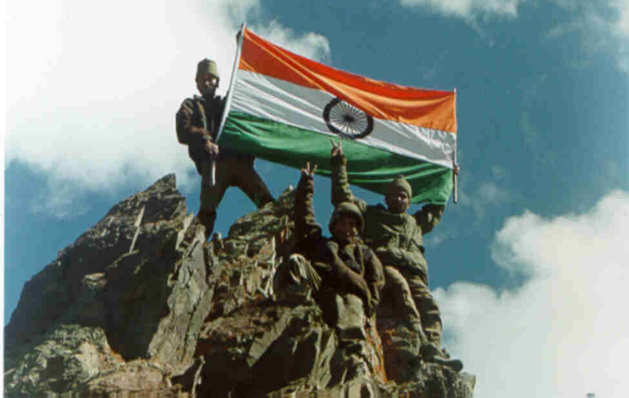
- Intelligence. This is an addition to the widely accepted principles of war because of its pre-eminence in any future conflict. Military Intelligence involves acquisition and exploitation of information about the enemy. Informatics plays a major role in ensuring that intelligence is available in time and in the desired form.
“War should be made methodically for it should have a definite object; and it should be conducted according to the principles and rules of the art”.
– Napoleon, Maxims of War, 1831.

SECTION 8 : OPERATIONAL READINESS AND EFFECTIVENESS
“The sword drawn to prevent the drawing of swords”.
– Samuel Purchas, Purchas His Pilgrimage, 1612.

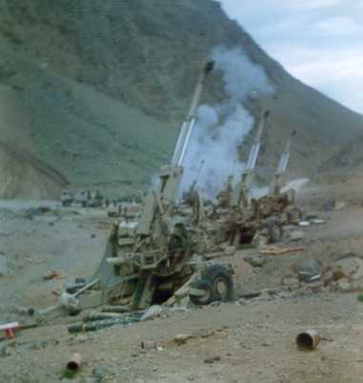
- Operational readiness is the state of preparedness of an organisation to perform the mission for which it is organised or designed. Military effectiveness is the standard by which the Army, from the platoon to the highest levels, is judged in peace and war. The efficiency with which operational readiness and effectiveness is achieved also needs to be optimised to ensure availability of maximum possible combat power when and where required. The level of operational readiness and effectiveness of a force has a major bearing on its ability to launch and successfully conduct operations. Ensuring operational readiness and effectiveness is a command responsibility.

Combat Power
- The term ‘combat power’ defines an army’s ability to fight. Combat power has three basic components and their inter-relationship is shown in the figure below :-
- The Conceptual Component. This can be described as the thought process behind the ability to fight. It is a vital component in that, commanders at various levels have the benefit of the concepts and doctrines evolved over a period of time as well as the experience of their predecessors. It also helps commanders to imbibe a common understanding of principles and yet allows the freedom of exercising individual styles of command. The conceptual component comprises principles of war, military doctrine and development. The contribution of principles of war and military doctrine towards accomplishing operational readiness and effectiveness has already been amplified in earlier sections of this book. Development requires knowledge, an innovative approach and a mind open to all aspects of warfare; this includes force organisation, structuring and equipping of various types of units. Commanders also need to keep abreast of developments taking place in the environment and should have adequate knowledge of management of change so that they can work as facilitators. The higher the level of a commander, the wider should be his knowledge horizon so that he can understand the necessity to implement the desired change.
CONCEPTUAL COMPONENT
(Thought Process)
Principles of War Military Doctrine
Development
MORAL COMPONENT
(Ability to get People to Fight)
Leadership Motivation
Basic Morality Management
PHYSICAL COMPONENT
(Means to Fight)
Manpower Equipment
Logistics Training
National Assets and Infrastructure
COMBAT POWER
(Ability to Fight)
- The Moral Component. The moral component concerns the ability to get people to fight. Maintenance of morale is a principle of war and, as such, embraces the moral and physical aspects of combat power. High morale stems from sound training, confidence in equipment and good administration as well as confidence in commanders, discipline, self-respect and clear knowledge of what is going on and what is required. Yet the ability to get people to fight is not just a question of morale; it also involves the following aspects:-
- Basic Morality. It is extremely important that the basic morality of individuals in the Indian Army is always above board. Professional honesty, courage of conviction, integrity, tolerance to accept reality and differing points of view are some of the essential qualities which should always be encouraged. The higher the position in the hierarchy, the greater should be the commitment to moral values. In addition, a commander should posses the courage to take hard decisions.
- Motivation. Soldiers who are well motivated, and well led work as a team. Teamwork breeds comradeship which, in turn, leads to pride in belonging to a team and fosters esprit de corps. Motivation thrives on a continuing sense of purpose and it is the job of the commander to instil this purpose. Although national will, reflected in Government directives, serves to give the soldier this sense of purpose, it is the responsibility of the commander to make soldiers fully identify with these. It must be clearly understood that leading soldiers in pursuit of causes that they do not understand is a daunting task.
  - Leadership. There are many definitions of military leadership. However, most simply defined, military leadership is the projection of personality and character by the leader to get soldiers to do what is required of them. Skill in the techniques of leadership is the foremost quality in the art of command and contributes very largely to success at all levels of war.
  - Management. Good management can have considerable bearing upon morale and on military effectiveness. It involves making the best use of available resources in accomplishment of the mission. Management skills are essential elements of good and efficient military leadership.
  - The Physical Component. The physical component is the means to fight. It is defined as the total means of destructive or disruptive force which a military unit or formation can apply against the opponent at a given time. The ‘total means’ include the organising and provisioning of the main elements of combat power which are manpower, equipment, logistics, training and national assets.
Operational Readiness
3.21 Readiness of the Indian Armed Forces to meet national emergencies is a facet of national level endeavour. It calls for a synergised effort by all instruments of the Government to ensure that these forces are moved to their areas of operations, fully-equipped and within an acceptable timeframe. The Government, on its part, would indicate and maintain a clear and strong resolve to go to war when it orders a general mobilisation. There may also be other methods of preparation for war even without ordering general mobilisation. On the part of the Armed Forces, they are responsible for ensuring that they are operationally ready, troops are in a high state of morale and units are appropriately trained to execute the missions assigned to them.
3.22 Military mobilisation in the Indian context involves considerable effort because of the wide geographical spread of the peacetime locations of our units and formations, the considerable extent of our borders and the multiplicity of agencies that need to coordinate their actions in order to make it effective.

